

TRAINING MANUAL
2011

The purpose of this manual is to ensure consistent communication with the client, in the most efficient manner possible leading to greatest added value sales per consultant. This is our current best practice and must be adhered to until we find a better way.

READING MATERIAL:

http://www.southafrica365.com/tour-operator-south-africa/

http://www.southafrica365.com/our-south-african-holiday-pricing/

http://www.southafrica365.com/african-safari-cost/

http://www.southafrica365.com/africa-travel-information/

The Role of a Sales Consultant

- All of our sales consultants must have experience in the destination that they sell, in order to provide expert knowledge
- Our sales consultants need to have excellent knowledge of the destination, accommodation and tours that they sell and need to keep up-to-date with changes that happen within the destination that they sell
- Our sales consultants need to constantly undergo and attend training sessions on selling techniques and product updates

Sales Management Process

Intermediate:
- There is a probation period within the ‘intermediate’ banding
- Smash targets consistently for the probation period will result in the promotion to senior sales consultant
- Not smashing targets consistently for the probation period will result in performance management

Senior:
- There is a probation period within the ‘senior’ banding
- Smash targets consistently for the probation period will mean you become a permanent senior member of the team
- Not smashing targets consistently for the probation period will result in the demotion back to ‘intermediate’ banding

Sales Targets
- Targets be based on the Financial Year: 1st March – 28th February
- Commissions and annual targets are calculated on invoice date.
- Monthly team bonuses (at management discretion) are awarded against the team contract and are calculated on booking date.
- Targets are ex Vat as per accounting standards
- South Africa 365 reserves the right to adjust targets should a new position and / or basic salary (not including inflation adjustment) be negotiated during the course of the year.
- On resignation, 50% of forward dated commission will be paid out

Contractual Targets for Southern Africa & East Africa

CONTRACTUAL TARGETS SA365 | STL | SENIOR | INTER. | ADMIN
CTC Basic Salary | R 14,000 | R 12,000 | R 8,500 | R 6,500
Minimum Monthly Sales Required prior to Employment Contract Performance Review (rolling 3 months avg incl VAT) | R159,700 | R174,200 | R132,033 | R82,367
Annual Target (incl VAT) | R 3,240,000 | R 4,050,000 | R 2,520,000 | R 0
Annual Target (ex VAT) | R 2,842,105 | R 3,552,632 | R 2,210,526 | R 0
Expected On Target Earnings Per Annum | R 235,200 | R 227,400 | R 144,720 | R 80,400

CONTRACTUAL TARGETS SAFARI 365 | STL | SENIOR | INTER. | ADMIN
CTC Basic Salary | R 14,000 | R 12,000 | R 8,500 | R 6,500
Minimum Monthly Sales Requirement prior to Employment Contract Performance Review (rolling 3 months avg incl VAT) | R173,533 | R188,033 | R142,533 | R90,700
Annual Target (incl VAT) | R 3,840,000 | R 4,800,000 | R 2,700,000 | R 0
Annual Target (ex VAT) | R 3,368,421 | R 4,210,526 | R 2,368,421 | R 0
Expected On Target Earnings Per Annum | R 247,200 | R 242,400 | R 147,600 | R 80,400

Sales Consultant Role Portrait

KEY ACCOUNTABILITIES | KEY FUNCTIONAL & SKILLS COMPETENCIES | KEY BEHAVIORAL COMPETENCIES | QUALIFICATIONS | TYPE OF EXPERIENCE REQUIRED
Smash targets and drive sales | Excellent spoken and written English including good grammar and punctuation. | Commitment | Higher education | Intermediate: 2 years + relevant sales experience dealing with e-leads from international inbound markets  Senior: 4 years + relevant sales experience, dealing with e-leads from international inbound markets  Team Leader: 4 years + relevant sales experience, dealing with e-leads from international inbound markets & relevant team leader experience.
Deliver customer service excellence at all times through all mediums | Itinerary Building | Customer Focused |  | Relevant product & destination knowledge within Africa
Provide expert destination and product knowledge | Sales | Results Driven |  | Travel through Africa Advantage
Showcase excellent communication skills at all times | Typing skills | Flexibility |  | Proven track sales record
Build and develop repeat and referral business | Demonstrate initiative to create new business | Innovative |  | Telesales to general public
Build company & self brand through social media platforms | Intermediate Word, Excel, Outlook (including task and calendar) | Self Belief & Confident People Person |  | E-mail sales to general public
Commits to efficient & timely response to client requests |  | Strategic Thinker |  | Face to face sales to general public
To execute those requests in the most efficient proven sales technique possible |  | Able to increase demand
Prioritise clients on greatest return of time (Intuition required on projected sale and ease of closing sale factor) |  | Excellent attention to detail
Attend sales team talks and technical sharing sessions
Lead Allocation

  - Geographically targeted leads will be allocated to the consultants either in that region or who specialize in that destination.
  - Preferable means of contact with the client is via telephone and then in person where possible, this will allow the consultant to build up a rapport and relationship of trust with the client.
  - The consultant should always discuss the ideal itinerary, showcasing their expert knowledge of the destination and products in order to illicit excitement for an ultimate African experience and dream holiday.
  - The consultant is to lead clients towards preferred suppliers and specials on offer that demonstrates the company’s competitiveness as well as having the client’s best interests at heart.
  - Should no phone number be available, an email contact should be pursued by the consultant.
  - The consultant is to facilitate repeat and referral business, by gathering client feedback and providing post-travel service.

The Booking Process

- Operational protocol for working within Sales Force must be followed.
- Operational protocol for working in Travel Logic must be followed.
- The full complete file of the client is to be sent to the dedicated email as stipulated by the company.

Sales Consulting Best Practices

(What makes them tick and ultimately book? The consultant that wins the customers confidence first will most likely be the one they book with)

- RESPONSE TIME is critical, always respond within 24 hours

- PHONE calls have a higher conversion rate, always phone if possible
- Provide our toll free numbers and your working hours

- Show that you are an EXPERT – through your knowledge of the destination (showcase this by telling them something nobody else will)

- Talk about your own EXPERIENCE in the destination where possible

- PROFILE the client before you send them a quote.
- Ask open questions about the client’s needs and probe their responses.
- If they ask for a specific tour provide them the details, but outline other better options for them where possible
- Once you fully understand their needs, explain that you will send them a quote within 24 hours. Put together your quote as quickly as possible – under promise and over deliver

- SERVICE - We know what we are talking about and have vast experience. We are a legitimate company and are not going to renege on what we offer, nor are we running off with the client’s money. Ensure your clients know they are in safe hands

- COMMUNICATION often with the client, ensuring you keep them up-to-date on when they can receive quotes from you and answer their questions quickly and efficiently

- Ensure you meet the clients EXPECTATIONS, for example if you tell the client you will call them at 5pm tomorrow, don’t call at 6pm. It is far easier to under-commit and over-provide. (i.e. – I am working on your quote and will get it to you by Thursday, when you supply it on Wednesday you are king) Always keep them informed. i.e. Hi John, thanks for your email, I am working on your quote and should have you an answer by next week, rather than keeping the client in that dark) Friendly and efficient are the perfect combinations.

- Create a sense of URGENCY around the booking, stress that no reservation has been made and that the quote is subject to actual availability at the time of booking.

- Build a RAPPORT with the client, encourage the traveller to let you know if they have any questions or would like to make any changes.

Our Service Offering

- We purchase products directly from our suppliers as opposed to middle agents, this allows our travellers better prices for value products

- We continually invest in our consultants by sending them on trips through-out South, Southern & East Africa to ensure they have phenomenal expert destination and product knowledge at all times.

- We market and sell tours, services and destinations that we believe meet the requirements of each individual traveller.

- We are able to secure the best for our travellers, ensuring their tailor-made African travel experience is a ‘once-in-a-lifetime’ experience.

- As we are African based, our rates structures are far superior to foreign based travel businesses and due to us working in the same region as our suppliers, our service offering and service speeds are superior.

- We offer our clients 24 hours client service whilst on their trips should the clients experience any issues or need help with anything.

- We offer our clients exceptional products at a competitive price, delivering perfectly tailor-made safari holidays by providing a complete, door-to-door and seamless package for the ultimate African experience.

- The Operator only enters into partnerships with suppliers who they have confidence in and who support their traveller-centric values

- The Operator consistently strives to improve their service offerings, maintain their competitive rates and growing their product portfolio through comprehensive customer feedback and effective market research.

- The Operator has impeccable credentials and has been established for the past 7 years.

- The Operator’s bookings automatically include bonding should The Operator become financially strained to the value of R75, 000 per booking.

- The Operator has established local bank accounts in the Clients Territory for ease of payment.
OUR PRICING

Since the global recession clients are shopping around and competition within the industry is fierce!

When a client comes to you saying they have got the same / similar quote cheaper somewhere else......
........you can email them the below.....

Many thanks for your reply and also your honesty in saying that you think our prices are too high. I would be more than happy to compete against any quote that you have received, so before you go ahead with the other quote please afford me the opportunity to see a copy of any competitors quote and I will endeavour to beat or match the quote.

South Africa / Safari 365 are experts in travel through Africa, we have the best relationships with all of our suppliers, this is what sets us apart from the competition, of course that and also the fact the we are also specialists who not only live in Africa but have visited the places we sell, so we can give you expert advice. Our aim is to provide you with a seamless dream vacation, provide value for money and the best holiday experience to suit you and your budget

- Rates on the website run at an average mark-up of 25%. If you feel that price is not an issue and the client is not shopping around, attempt a higher mark-up as long as the client is not being ripped off and paying above rack (and only on package prices where the components cant be added up.)

- Sell at a higher rate when the client is stuck, no other availability and you are holding the last room (never above rack) 24% - 27% is the optimum selling mark-up and are the rates on the website. If we get a STO rate of 25% and mark-up 24%, the selling rate will still be 7% below rack (see graph below) If you are getting an STO of 35%, you know that you can mark-up significantly and still come in well below rack rate.

- Try and work out how much the client is comfortable with spending early.

- The last thing that you want is to loose a client due to being undercut by the competition, especially on big deals. Be prepared to negotiate downwards rather than loose a deal, but not below 18% mark-up. If you are being undercut on one particular leg of their booking, play to their fears that it is risky booking via various operators as mishaps can happen in coordination of the vacation.

SCENARIO | A | B | C | D | C
Rack | R 1,000 | 1000.00 | 1000.00 | 1000.00 | 1000.00
STO | 15.00% | 20.00% | 25.00% | 25.00% | 30.00%
Nett | R 850 | R 800 | R 750 | R 750 | R 700
Markup | 0.12 | 0.19 | 0.24 | 0.27 | 0.36
Selling Price | R 952 | R 952 | R 930 | R 953 | R 952
GP | R 102 | R 152 | R 180 | R 203 | R 252
Discount to Rack | -4.80% | -4.80% | -7.00% | -4.75% | -4.80%

- The pricing should is not all inclusive and shows the breakdown of costs in the booking confirmation (clients seem to prefer this as many operators don’t do it).
- Only some South African clients need a tax invoice, and these will have the breakdown of items and tax.
- For a booking that has more than one component, add all of the nett costs and mark up (24% or more) but not above rack.

- Do not price yourself out of the game where the supplier has given good STO’s to all operators (i.e. Legacy)
- Do not give away the profit where we are getting exceptionally good STO’s (i.e override markup upwards)

Product Tips

- MODULATED PRODUCT OFFERINGS – The tours and Safaris on the self-drive website have been designed to offer what clients are asking for. They have also already been fully costed and routing/transfers done. They use the preferred suppliers which we want to build relationships with. Try to use the modulated components from the X-cell document, or send them to the website tour that matches their requirements most. If their requirements don’t match exactly, break the tours down into components and compile to make an itinerary. The tours can obviously be tweaked to meet their exact needs. Use the site to reduce workload and speed up efficiency.

- EMAIL OUTLOOK CONFIGURATION: Please adhere to the standard Microsoft Outlook configuration (where clients are placed in folders according to the month of their booking, by first name and then surname)

- B’CC: for all new consultants during your first 2 months at SA365, please b’cc sales your manager within correspondence between all clients from initial to 3rd contact. This allows us to quickly identify changes/improvements in selling technique.

- AVAILABILITY BOOKING PROPTOCOL: Always check the availability directly with the supplier / ground handlers and respond to the client. If you there is currently availability and you fear that when the client gives you a yes response the availability will be gone, hold the room putting urgency on the client to book.

- ALTERNATIVES: if a hotel/game lodge is full, always offer alternatives when telling them the first choice is full. If it is a well headed client (and accommodation of choice is available), also offer alternatives that are more expensive so the client sees the 1st choice as good value.

- ACTION: Make sure that they realise the action and respond to it: “ Please see the following lodges and let me know your thoughts”, “I think that XX is most suitable and have held a provisional booking on your behalf, please let me know if I should go ahead and fully confirm and we can secure the rest of your booking as we proceed”, “”would you like XX or do you think YY is better suited?”

- BUILD THE EXPERIENCE WHEN CREATING ENQUIRY: end of on a high if possible (i.e do not sent clients to Okavango (chilled area) after Linyanti (plentiful game and wow factor). Also applies for rooming, if splitting room types within a hotel or series of hotels, rather upgrade their accommodation for the latter stay than downgrade it.

- PERSONAL POINTS: in the initial response, ensure the reply template has been adapted to include AT LEAST 2 PERSONAL POINTS, where you pick up on any key attribute that the customer is looking for and make the response unique, letting the customer feel that YOU UNDERSTAND THEIR NEEDS BEST from all of the responses they may get. This could be giving them a hint on a romantic restaurant is they indicated romance in the enquiry, or giving them the inside track on a hotel that will be just what their kids are looking for – whatever. We do not have a traditional ground handlers/international travel agents relationship, where the travel agent has a contract in place with the ground handler and has to book with the SA ground handler – we need to WIN OVER EVERY CLIENT before they book!!

- ADVICE: We are NOT booking agents (as if we were booking process agents they may as well book online with no human interaction) We are travel experts specialising in the destination we know and love. Use your human intuition to understand the client, then guide and help them to book the most suited accommodation/tour/safari for their needs. As soon as they feel that you understand their requirements, they will stick with you. Giving of your information and input freely will lead to closing sales.

Preferred Suppliers

PREFERRED SUPPLIERS LISTS
- This is our Bible and needs to be adhered to. Subject to availability, promote our preferred suppliers where possible.
- Our preferred supplier list can be found here:-

Payment Methods

- Payments via credit cards cost South Africa 365 and consultant commission. Payment by bank transfers cost the client. Always try and get the client to pay via bank but not to their detriment, send “how should I pay document” and let them make the ultimate decision. ( I will design this once a foreign bank account is set-up) South African clients must do a bank transfer.

LIVEZILLA

Mapping Software

Operational Protocol for working in Travel Logic

ALL ENQUIRIES MUST BE CAPTURED (INCLUDING ALL PHONE CALLS AND REPEAT/REFERRAL)

- Every enquiry must be loaded into TL (including phone requests) and dump the excess information of the enquiry into the notes field.
- When phone number provided, phone before you start the quotation
- Preferred partners list
- Only “confirm the booking” at the same time you are ready to “invoice the client” (i.e. he wants to pay and the booking is going ahead)
- when you invoice the client (and are creating the accounting document) – be sure to use the accounting document footer and not your personal footer (as the accounting document footer has terms and conditions, legal stuff etc in it)
- CC accounts1@southafrica365.com on every invoice that leaves the office (this is vital)
- Payment reference number is the auto-generated INV number (which accounts will have a record of)
- Hand all documents to accounts once payment has been received (accounts will advise)
- Make the itinerary flow using the Supplier “*”. These have been carefully worded to up-sell and cross sell services, and are loaded for all main sales areas.
- Be careful on quoting NON-CONSORTIUM SUPPLIERS on Sun International TL rates. These are loaded on STO-000 (30%) and we are working on STO-00 (20%). (Other difficult suppliers???)
- On the last working day of every month, please go through all your open tours and cancel those that are not going to materialize (this list is potentially going to get very long if this is not done and it will slow your computer system) The data is always stored if you want to re-open it at a later stage. (see point 8 below in sales technique)

TRAVEL LOGIC SETTINGS

- Travelogic needs to be setup as per the below for the specified reports;-

SUMMARISED ITINERARIES

Run the “Summarised Itinerary” tab and not the “Itemised Itinerary”
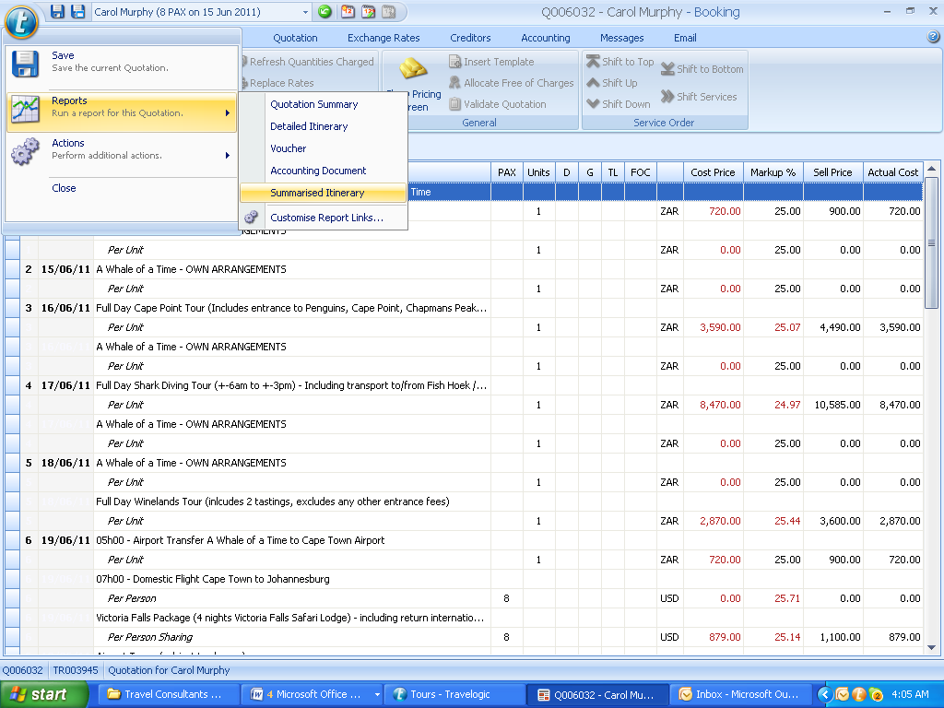

Ensure the settings are consistent with below:
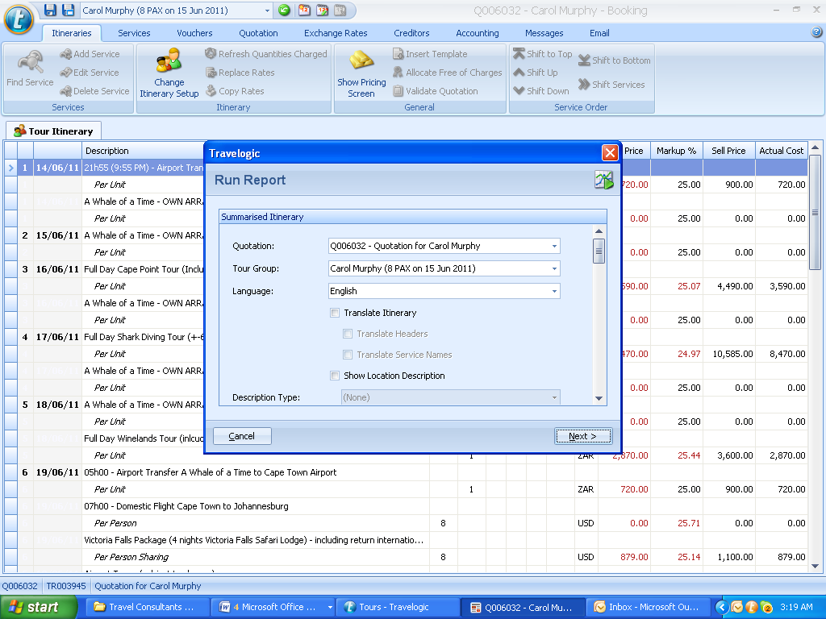

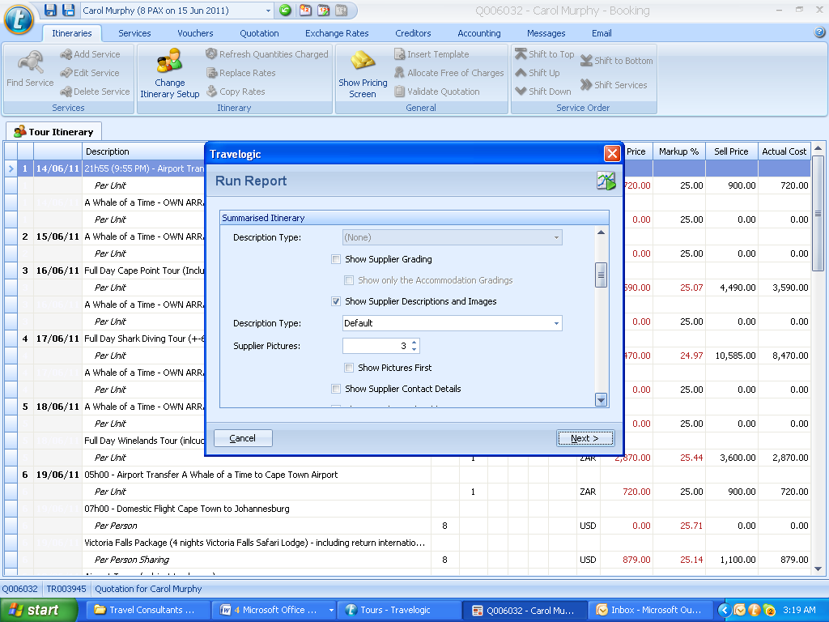
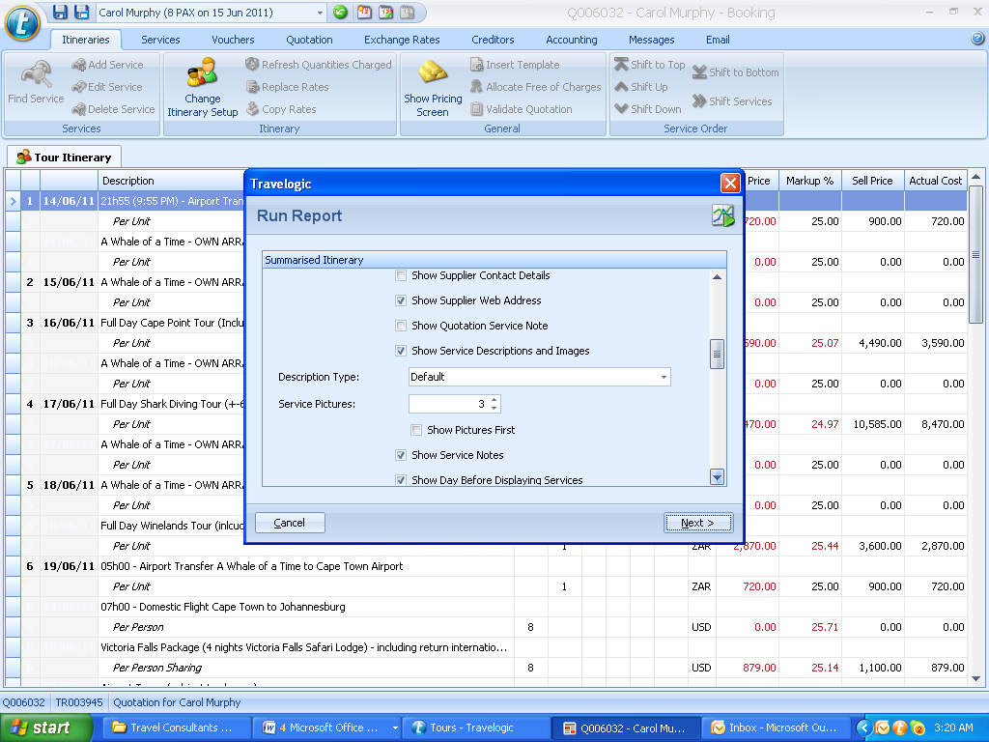

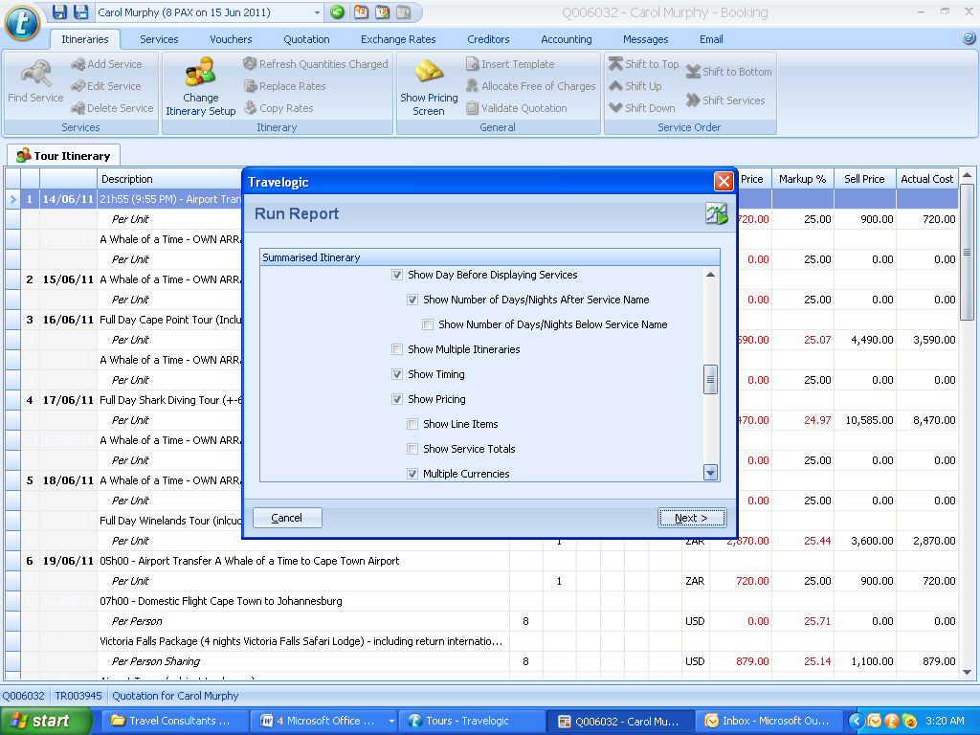
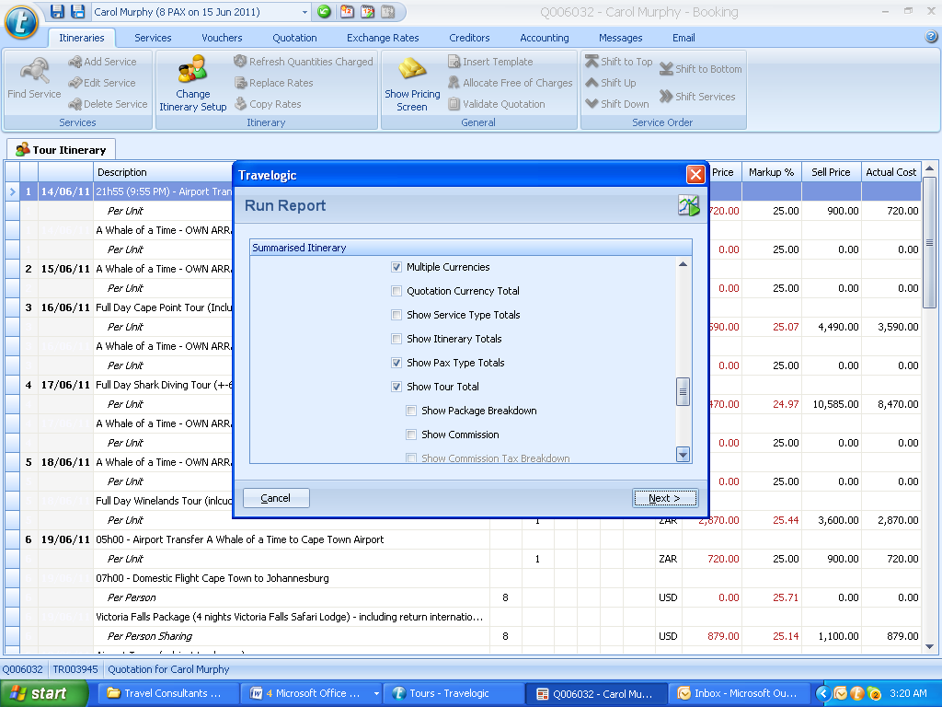

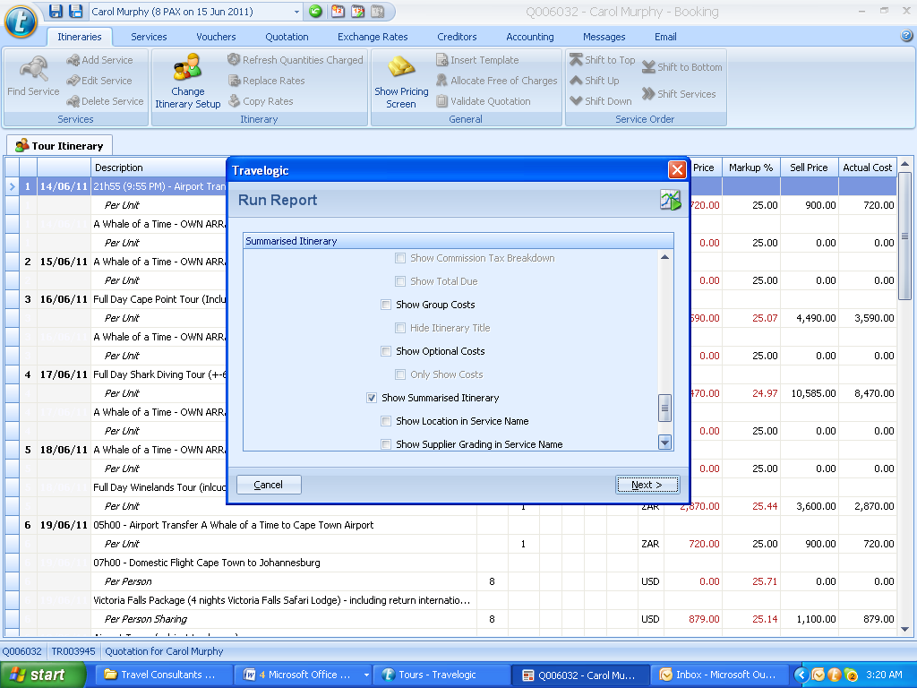
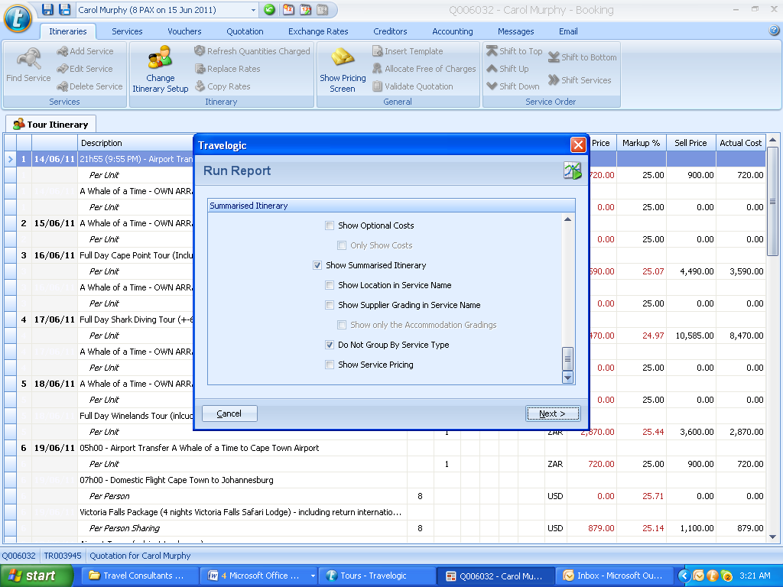

NOTE: THE “SHOW SERVICE PRICING” TAB IS ONLY TO BE TICKED IF THE CUSTOMER DEMANDS AN ITIMISED ITINERARY.

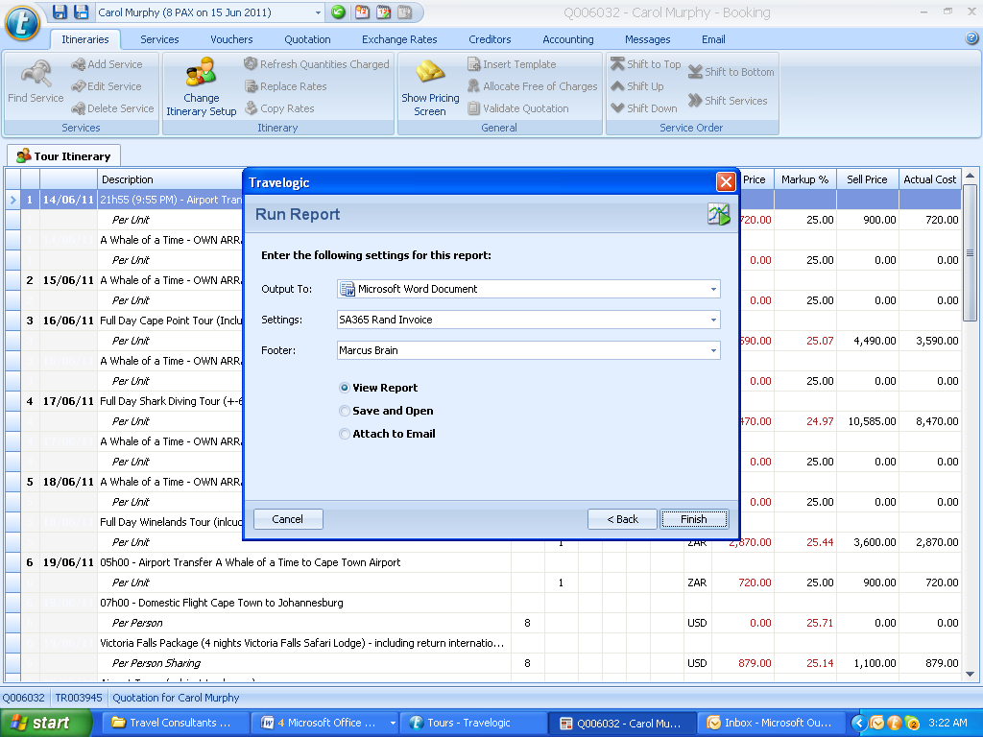

PLEASE ENSURE THE “FOOTER” ON THIS REPORT IS YOUR NAME.
PLEASE ENSURE THAT ON THE “SETTINGS” TAB YOU HAVE SHOWN THE BRAND TEMPLATE YOU WANT TO WORK FROM.
ONCE YOU HAVE MADE CHANGES IN THE WORD DOCUIMENT, CONVERT TO PDF BEFORE SENDING TO THE CLIENT.

ACCOUNTING DOCUMENT

Generate the new pro-forma invoices before running the “Accounting Document report”

Double click on the Pro Forma invoice to add in deposits and balances due plus dates. (Balance date to match the invoice date) make the transaction type “Electronnic”
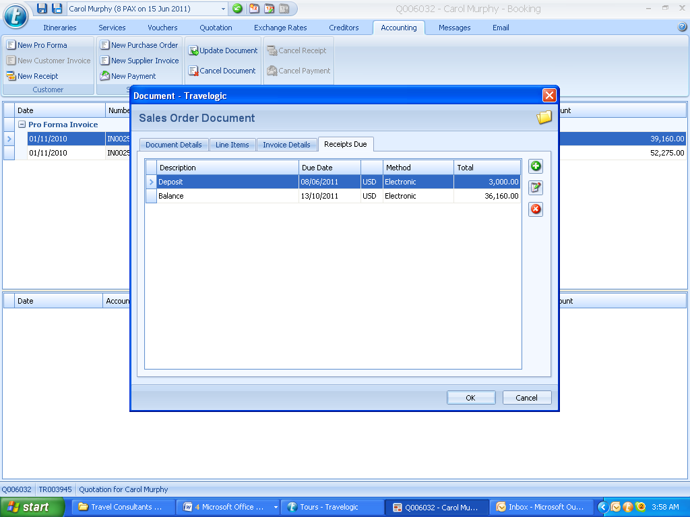

Run the report for the new Pro-Forma Invoice as an “Accounting Document”

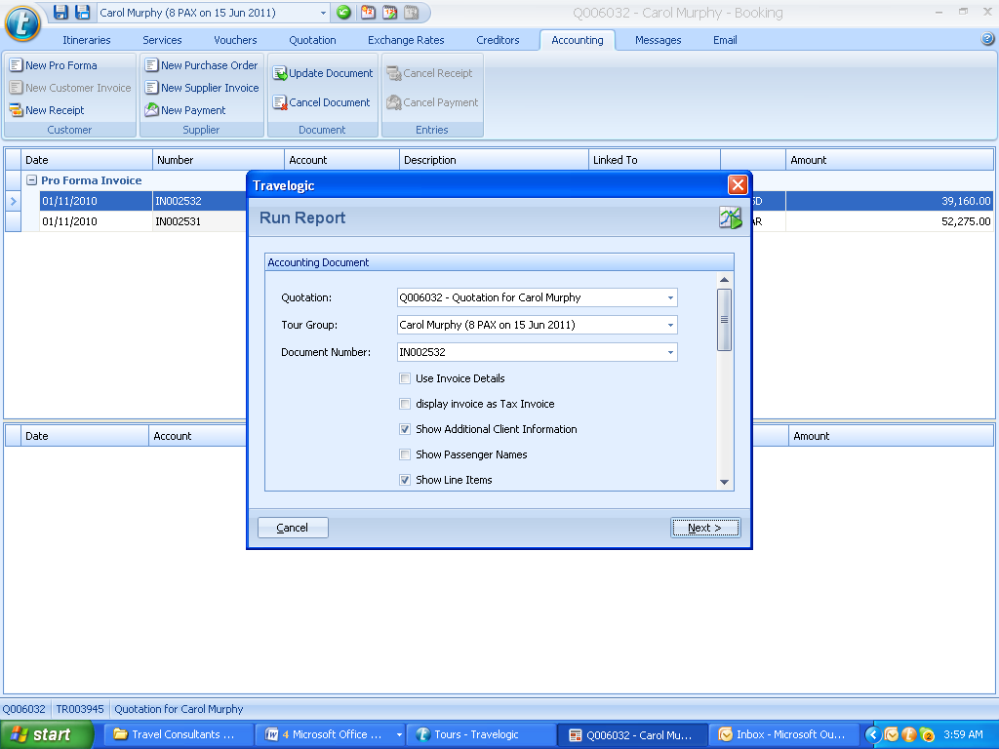

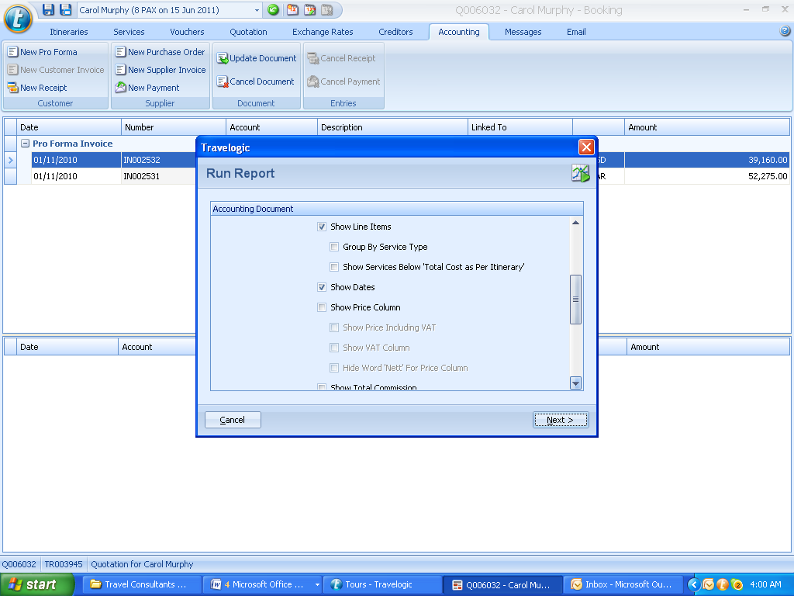

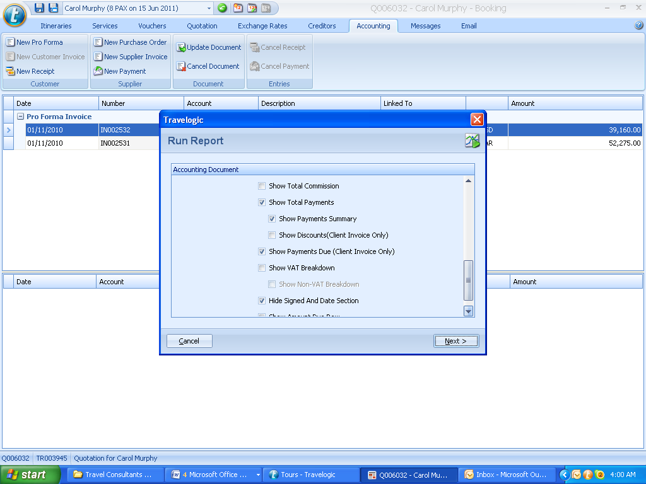

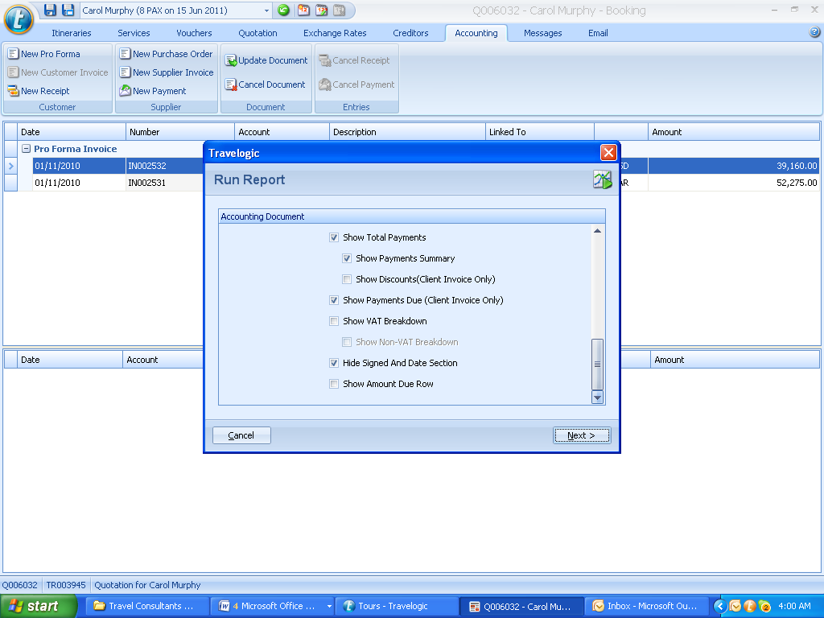

Choose the correct “Setting”
NB: choose the footer as “Accounting Document” (this has legal ramifications if not done correctly)
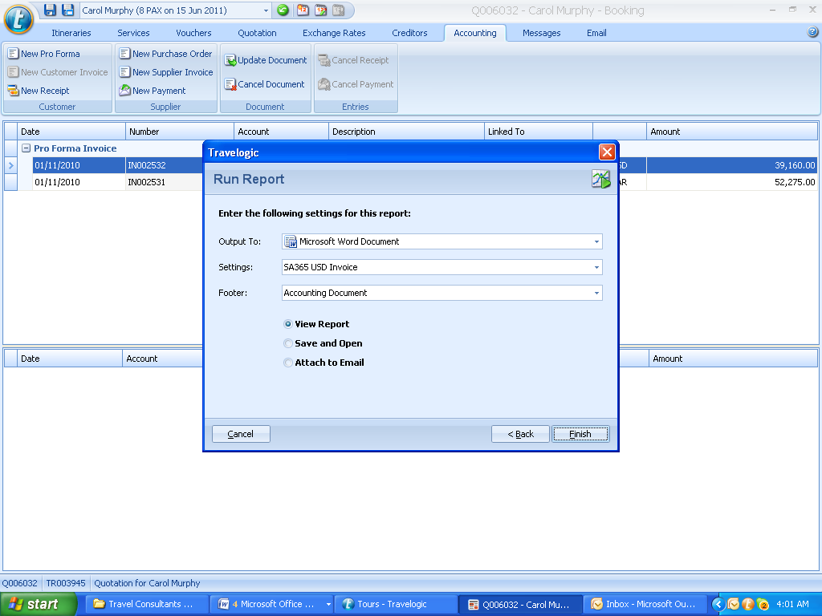

VOUCHER DOCUMENT

Autogenerate Vouchers for the required service and run vouchers
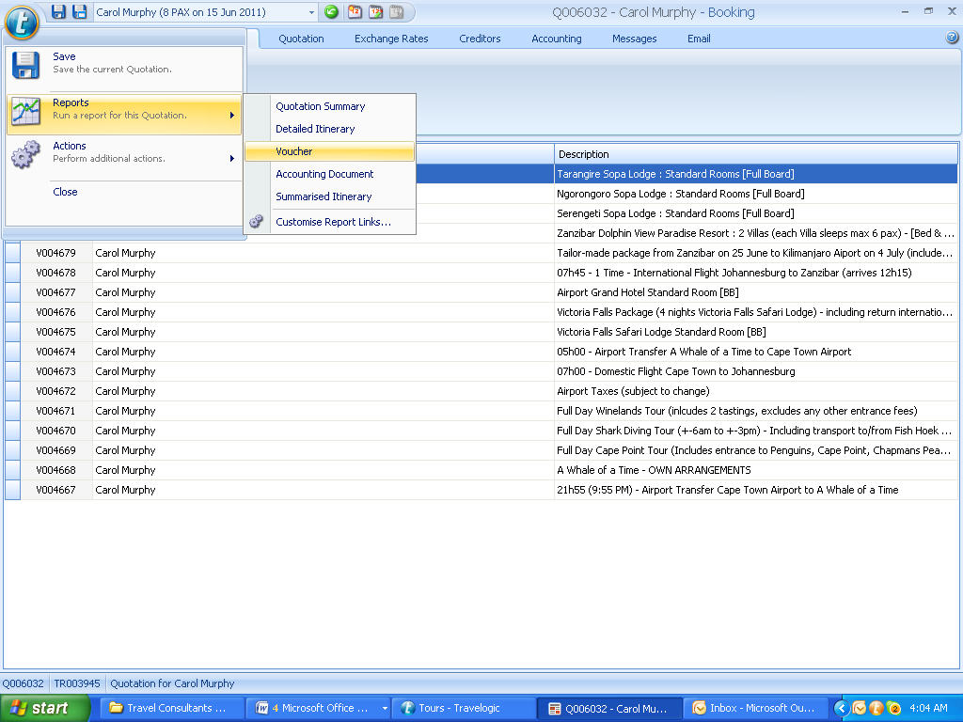.

Setting up Travel Logic Remotely

- To setup the access of the Travelogic™ remote connection you need to go the path or directory C:/Program Files/Travelogic/Client.
- Open the “Client” folder and look for a file that says “server connection”, delete the file and look for a folder named “Updater.”
- In the Updater folder there is a file named “server connection” please delete that file as well.
- 8. Click on the Travelogic.client.updater icon, this will prompt you for a server name/address with ports 8090 automatically filled in.
- 9. Please enter the following URL into the blank field Server365
- 10. This will do updates from the server to your PC or Laptop
- 11. Please make sure that all the Updates get done 1 to 26.
- 12. Once the Updates are done you it will open into the “Welcome Screen” with a server connection window open please enter the same URL into the blank field for the server name\address. Server365
- 13. The Application name will be Travelogic
- 14. Then login using your Travelogic™ details and that should give you the connection to the new server.

Branding

All email font and word documents to be in font – Arial 11
Please set up your email signature exactly like this:

Safari 365

Marcus Brain
Managing Director

switch:+27 21 4621928
fax:+27 (0) 866581713
cell:+ 27 82 579 8890

physical/postal: Suite 301,
The Hills Building, Buchanan Square,
160 Sir Lowry Road, Woodstock, 7925

South Africa 365 provides tailor-made and group travel solutions to Southern Africa for the independent traveler.
Destinations: South Africa - Botswana - Zambia - Victoria Falls - Mozambique - Namibia
Websites: www.southafrica365.com - www.capetownhotels365.com
South Africa 365

Kind Regards,
Blair Callon
General Manager
SA Tel: +27 (0)21 418 1325 (ext 209)
Fax: +27 (0)86 658 1713
Cell: +27 (0)82 904 8689
physical address: 3 Old Marine Drive, Foreshore, Cape Town
postal address: PO Box 189, Cape Town, 8000, South Africa


Points for 1st reply to enquiries

- If a client enters into a dialogue (responds) after an initial enquiry reply, it is seen as a successful reply. The objective is to increase the percentage dialogues (responses) from initial enquiry reply’s, therefore committing the client to SA365 / Safari365 and not letting him entertain other options when booking his/her vacation.

- No two responses will ever be exactly the same, and there is no hard and fast correct method of replying, each enquiry needs to be accessed individually and responded to accordingly.

- Please ensure our sales consultant best practices and service offerings are adhered to.

- Subject line of the reply:
  - South Africa 365 – Name – Detail of Requested Travel
  - South Africa 365 – John Jones – Garden Route Holiday

- Limit the amount of attachments to a max of 4. Put “Introducing South Africa 365.pdf” first and then the other sample itineraries.

- Salutation:
  - On the first email response: “Dear John,”
  - On the 2nd reply you can be more informal: “Hi John,” (depending on how the client addressed you)

STANDARDISED EMAIL REPLY TO AN ENQUIRY

Dear XX,

Thank you so much for your enquiry with South Africa 365 for XXX. I will certainly be able and happy to help you with this request.

My name is XXX and I will be your dedicated travel consultant. I have taken the liberty of attaching a document letting you know a little about myself, and introducing the South Africa 365.

Based on the information provided in your enquiry, I have attached a few of our sample itineraries that I thought might suit you and to show you what we are capable of. I am able to design a tailor-made itinerary to suit you more perfectly, once I hear back from you with your thoughts.

- South African Highlights Tour: 12 days – self drive tour - Cape Town, Hermanus, Garden Route and Safari.
- Cape Town and Kruger Special: 8 days – fly/drive tour - Cape Town and the Kruger National Park.

Personal info paragraph to win them over with other information (I would suggest… I notice that…a good alternative is...congratulations on the upcoming…etc)

Please let me know your thoughts on the suggested itineraries and answer a few questions that will help me immensely in planning your vacation: (max 5 questions, erase others)

- Have you been to South Africa before?
- Please give me an indication of your holiday budget?
- Do you prefer hotels, guest houses or B&B accommodation?
- How long will you have for this holiday?
- How many people will be travelling in your group?
- Are there any particular areas or sights you have heard of and would like to see?
- Would you be able to give me a budget per person for your entire trip (excluding international airfare)?
- Would you prefer a relaxed or more adventurous holiday?
- Are you happy to drive yourself, or prefer for me to arrange transfers and day tours?
- What ages are the people in your travel group?

Please let me know if you require any more information. Also, if you would like me to give you a call to have a quick chat please let me know (and provide your telephone number and a suitable time) and I’ll be most happy to contact you.

Thanks again XX client name for getting in contact with our organization and for this opportunity to quote on your vacation. I look forward to hearing back from and helping you further

Best regards,

STANDARDISED EMAIL REPLY TO AN ENQUIRY ASKING FOR HOTEL ACCOMODATION

Dear XXX,

Thanks so much for your enquiry with South Africa 365 for your hotel accommodation at the XXXXX. I will certainly be able and happy to help you with this request.

My name is XXX and I will be your dedicated travel consultant. I have taken the liberty of attaching a document letting you know a little about myself, and introducing the South Africa 365, as well as a list of the day tours we can arrange whilst you are in Cape Town.

I have just checked availability at all XX hotels and The Place on the Bay is fully booked at the moment. The following hotels have availability from XX to YY (ZZ nights).

Hotel Name | The Bay Hotel | Place on the Bay Hotel | Cullinan Hotel
url | www.thebay.com | www.thebay.com | www.thebay.com
Hotel location | Camps Bay beach area | Camps Bay beach area | Cape Town CBD
Room type | Club classic double | Club classic | Club classic
Our discounted rate per room per night | ZAR3000 | ZAR3000 | ZAR3000
Total accommodation rate | ZAR 15,000 | ZAR 15,000 | ZAR 15,000
Approximate USD/GBP total rate | USD 1200 | USD 1200 | USD 1200
Inclusive | Breakfast and all tourism levies and taxes | Breakfast and all tourism levies and taxes | Breakfast and all tourism levies and taxes

To check exact exchange rates pleas see this link: http://www.xe.com/
Please click here to see a detailed map of the location of these hotels: http://www.capetownhotels365.com/map.htm

Please let me know if you would like me to confirm a reservation for you. I will require the following information:

- Full names of guests (as in your passport):
- Dates of birth for guests:
- Double bed or twin beds required:
- Any dietary requirements:
- Arrival and departure details:
- Contact telephone number while in SA (if available):

Please note that I can also help with airport transfers, day tours (see attached) and any other tours and safaris throughout Southern Africa (please see www.southafrica365.com for more information)
Thanks again XX for getting in contact with our organization and for this opportunity to quote on your hotel accommodation. I look forward to hearing back from and helping you further.

Have a wonderful day☺

STANDARDISED EMAIL FOLLOW UP AFTER 4 DAYS OF NO CONTACT
Dear XXX,

Hello again from a sunny Cape Town. This is a follow-up to ensure that you successfully received my earlier email regarding your vacation to XX destination of interest.

EITHER USE THIS (FOR CREATING URGENCY IF THE BOOKING IS LESS THAN 3 MONTHS AWAY)

We realise that your proposed dates for your vacation are less than XX weeks/months away and, so as to be able to guarantee availability and avoid disappointment, we are eager to start assisting you planning the perfect vacation ASAP.

OR THIS

We realize that planning the perfect vacation is a very involved process. Although we know that our clients book with us due to the superior service they receive, we also realise that it is equally important to receive maximum value on your vacation. For this reason, we have introduced our “Best Rate Policy”. Basically, if you are considering booking with a competitor of ours due to a discrepancy in the rates we quoted, send us their offer and we will be more than happy to provide you with a comparative quotation.

Please advise if you would like to proceed with this booking or if I should close your file.

Looking forward to hearing from you and helping you further,

Kind regards,

LOST CLIENT RETIEVAL LETTER
Dear XX,

I thank you for the opportunity you have afforded South Africa 365 thus far on quoting on your holiday requirements. I have discussed your booking in full with Bernelle and overseen your file progress from original contact on xxFebruary 2009.

I realize that you are now at a crossroads in your decision making, and assure you that we remain committed obtaining your business and providing you with top class travel services. Due to the resources that we have already committed to this booking, I thus request you afford us the opportunity to quote against any competitor that may also be pitching for the work. We are confident that when comparing apples with apples, you will note that our service and pricing is unmatched and you will be making the right decision by booking with us

Kind regards,
PAYMENT AND DEPOSIT (ZAR)

Dear XXX,

Thank you for booking your travel requirements through South Africa 365.

Please find your invoice attached, as well as payment instructions below in order to confirm your reservation. Once payment has been successfully received, I will be sending you relevant vouchers or any other applicable documentation.

PAYMENT INSTRUCTIONS:

Amounts payable and due dates are as shown below.
Payment must be received within 48 hours of due date or bookings will be automatically voided.

Type | Amount | Due Date | Payment Reference
Deposit |  |  | INV1026 d
Balance |  |  | INV1026 b

Payment can be received by bank transfer or by credit card, as both methods have their advantages. Please let me know if I should send you further details on the various payment method advantages.

Payment via Credit Card:

South African Rand payments can be paid online with your credit card by following this link: http://www.southafrica365.com/payment

Payment via Bank Transfer:

You can pay directly into our bank account below:

Bank: First National Bank
Account Name: South Africa 365 Travel cc
Account number: 62090696728
Branch name: FNB Sea Point, 6 Regent Road, Sea Point, 8005
Branch number: 201 809
Swift: FIRNZAJJ

PERSONALISE It has been a great pleasure assisting in you planning your vacation and I am certain you will make wonderful, lasting memories. Please do not hesitate to contact me should you require anything further.

Best Regards,

(EMAIL SIGNATURE)

PAYMENT AND DEPOSIT (USD)

Dear XXX,

Thank you for booking your travel requirements through South Africa 365.

Please find your invoice attached, as well as payment instructions below in order to confirm your reservation. Once payment has been successfully received, I will be sending you relevant vouchers or any other applicable documentation.

PAYMENT INSTRUCTIONS:

Amounts payable and due dates are as shown below.
Payment must be received within 48 hours of due date or bookings will be automatically voided.

Type | Amount | Due Date | Payment Reference
Deposit |  |  | INV1026 d
Balance |  |  | INV1026 b

Payment via Bank Transfer:

Bank: First National Bank
Account Name: South Africa 365 Travel cc
Account: 0173576
Branch: 201 809
Swift: FIRNZAJJ

Physical address:
FNB Sea Point
6 Regent Road,
Sea Point,
8005

PERSONALISE It has been a great pleasure assisting in you planning your vacation and I am certain you will make wonderful, lasting memories. Please do not hesitate to contact me should you require anything further.

Best Regards,

(EMAIL SIGNATURE)

Handover OF FILES TO ACCOUNTS

- Await payment received (accounts to advise)
- Handover file (Front of file to have client invoice, then all supplier invoices in correct order, then all other documentation) ( no need to print all of the correspondence)
- It is the Travel Consultants responsibility to ensure that all documentation on the Booking Confirmation and an all invoices from the suppliers are correct and bookings are confirmed/dates match. Once the Booking Confirmation has been completed and emailed to the client, the full documentation must be handed over to Accounts. From here it will be their responsibility.

ACCOUNTS DELIVERABLES

Online Credit Card Payments

- When instructing clients to pay online via CC reference number used should be the INxxxx number on the invoice generated in travel logic. Please note, drop the ZEROS in the INxxxx number.

- Invoicing will only be accepted as generated in Travelogic as these numbers are sequential and traceable.
- There will be cases when clients are having problems with online payments, please have the client supply you with following details:
  - Names on credit card
  - Credit card number
  - Expiry date
  - 3 digit security code at the back of card or 4 digit in cases of Amex cards.
  - Telephone number where they can be reached.
  - Type of card (Visa/Mastercard)?

You will then try process the transaction through our online payment gateway. Should it fail please hand file to accounting office to try and get a voice authorization from merchant services.
- All consultants will receive emails on daily basis informing them of all online transactions as well as bank transfers. Please provide as much detail as possible to the finance office to ensure funds are allocated to the correct client.
- Client files (client invoice and supporting supplier invoices) are to be handed over in hard-copy form ONLY. Please print all invoices staple and hand to the accounting office. In cases where suppliers are not in position to provide invoices, get a confirmation in writing stating the price.

Bank Deposits / Transfers

- In cases where clients opt to pay via bank deposits, please have them use their names and invoice number as the reference for the transaction.
- Bank transfers can take 12 – 96 hours to reach our account. In cases of urgency, please ask the clients to send a copy of their balance of payment (BOP) form(s) to facilitate an easier trace of the funds.
- Please also note that all transactions equal or greater than 50,000 zar irrespective of the currency require that we fax a copy of the client invoice to the bank to complete the transfer, please ensure that this is available to the accounting office.

Training on New Payment System
- This will occur once the system has been tested and built, projected early Feb 2011.

Supplier Payments, etc

- Consultants are to ensure that supplier invoices have complete supplier information i.e. banking details, email address, etc. before handing in files
- Clearly indicate the due date of the supplier. In some cases however the accounting office will negotiate the terms of payments and you shall be notified of this.
- Proofs of payment shall be emailed to the email provided by supplier and a copy to the respective consultant.
- Instances that require a payment be made prior to the client file being closed will require an invoice from the supplier as well as the client details. The hard copy of the document will be handed back to the consultant (with the PAID) stamp on it and resubmitted once the file is complete.

SALES FORCE PROCESS

LEADS

Management assigns leads
Management states if high/med/low
1st contact by phone

- Please ensure you update your ‘Lead Status’ within SF
- As soon as you have sent your first consulting email – change the status to ‘Contacted’
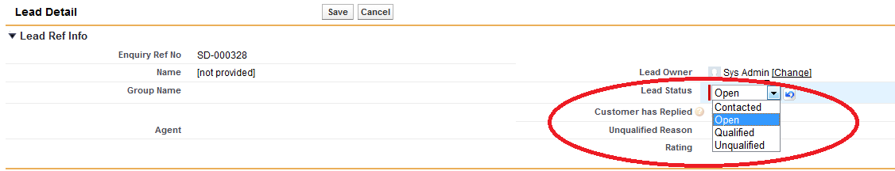

- We have agreed to remove ‘Qualified’ as a lead status, as this is the same as converting a lead to an Account
- A lead becomes an ‘Account’ once we have received a response from the client showing intention to travel with us
- Once we have “Contacted’ the client we will wait 2 days before sending a follow up email,
- If the consultant deems the lead to be ‘Hot’ – they will then use their own discretion on how many follow up’s they wish to send
- If the consultant deems the lead to be ‘Cold’ – they will use their own discretion about sending a follow up email vs. Closing the lead
- As soon as the consultant marks the lead as ‘Unqualified’ they will be asked to add a reason from the drop down box.

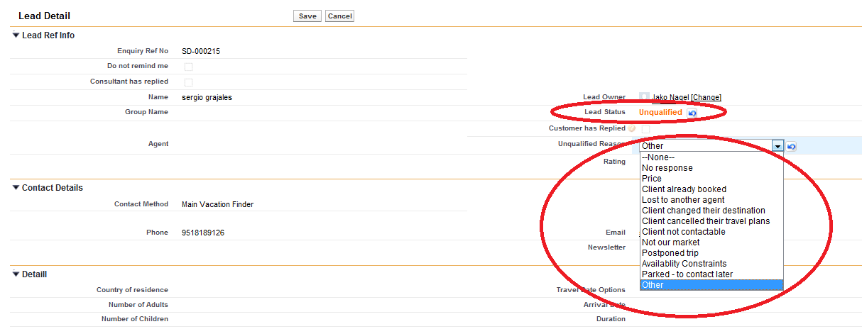
OPPORTUNITIES

- You may have several opportunities against an account. It’s important to keep the ‘Opportunity Stage’ updated against all open opportunities
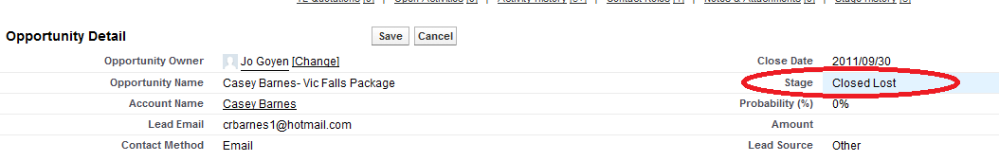

- When you ‘raise a quote’ within the opportunity – the account will be automatically created in Travel Logic.
- The consultant can then create the account in Travel Logic as per normal and the quote and figures will pull through to Sales Force.
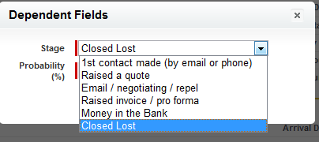

- If you mark an opportunity as ‘Closed Lost’ you will then be required to chose a reason from the drop down box:-

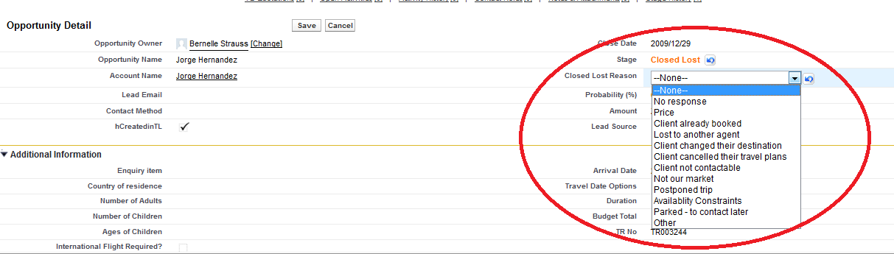

- Every email must be synced to SF

- Status must always be kept updated

- Call recording (call recordings on a monthly basis)

How to Handle Repeat Clients in Sales Force

A repeat client will either send an enquiry through the website (as per a normal lead) or they will send you an email:-

- If they send an enquiry then the lead will go straight into SF as per normal
- If they send an email – then the lead will need to be manually created in SF

How to Add a New Lead to SF

- Click on ‘New’ which can be found within any of the lead views

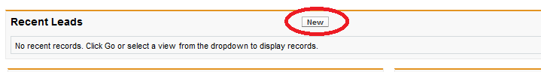

- Make sure you fill in
- First Name
- Last Name
- And one or both of the contact details (email / phone)
- Assign the lead to yourself
- Hit ‘save’

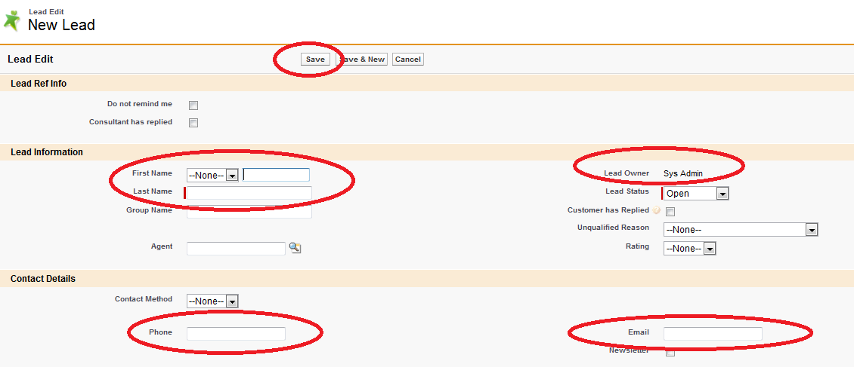
- Once the lead has been created you need to then ‘convert’ the lead to an account

- You will be taken to ‘Convert Lead’ screen

- If the client is a repeat client then, then under ‘Account Name’ there will be an option showing with the original ‘Account Name’ that was used. Make sure you select the original account name. If it is not a repeat client then you will not have that option (and you will only be able to select ‘create new account with clients name’ – as per screenshot below’

Alerts / Pop-ups (Task & Phone)

This is something you have to set up within your own settings (customized per user by the user)

- Go to Setup at top right hand side
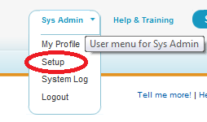

- Select ‘My Personal Information’ – ‘ Reminders

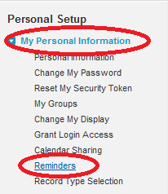

- You need to tick the options that will work for you & once happy you can ‘Preview’ what the reminder will look like
- Once you happy click on ‘SAVE’

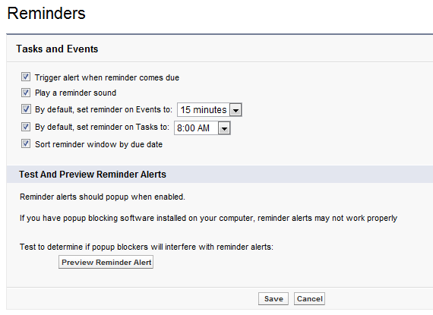

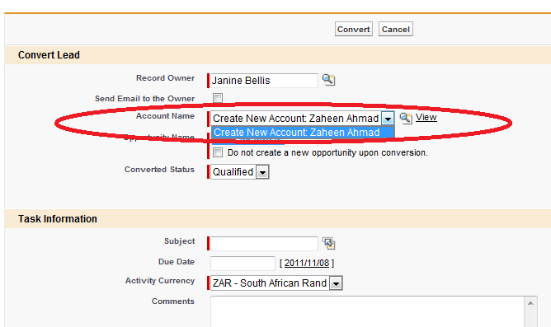

- Once you have selected the Original Account Name – then you would go and raise a quote as per normal.

